Under Maintenance

In the QuickDRYInstance folder there is a file

UnderMaintenance.php

This can be modified to fit the theme and marketing style of your project. It does not use a master page. It is expected to be a self-contained webpage without a code behind page to go with it.

To turn on the “Under Maintenance” page for the entire site:

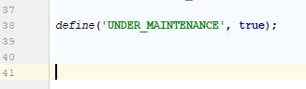

You can either set it to false to turn it off or remove the define entirely.